How to Install Windows 11 Without a Microsoft Account (Current Method)
For current release builds of Windows 11 (24H2), there's a simple trick for setting up Windows 11 with a local account that involves issuing a command to keep the OOBE from requiring Internet and then cutting off Internet at just the right time in the setup process. This works the same way whether you are doing a clean install of Windows 11 or following the OOBE process on a store-bought computer.
1. Follow the Windows 11 install process until you get to the "choose a country" screen.

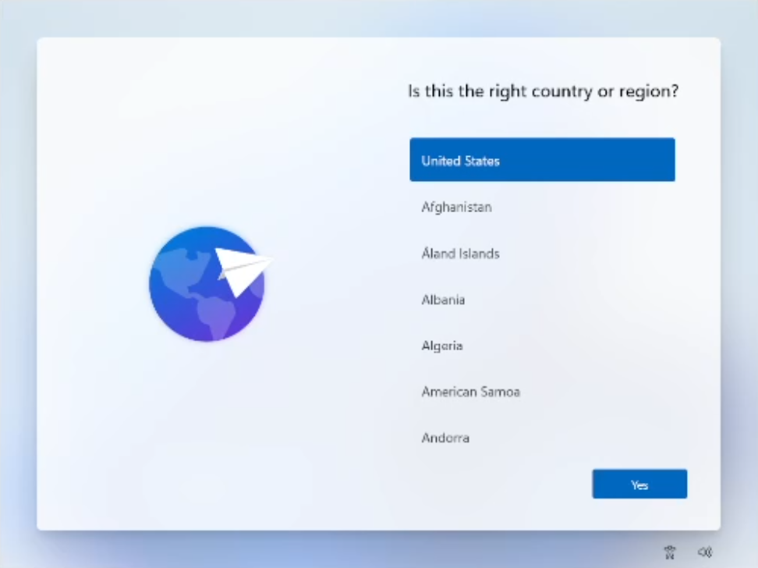
Now's the time to cut off the Internet. However, before you do, you need to issue a command that prevents Windows 11 from forcing you to have an Internet connection.
2. Hit Shift + F10. A command prompt appears.
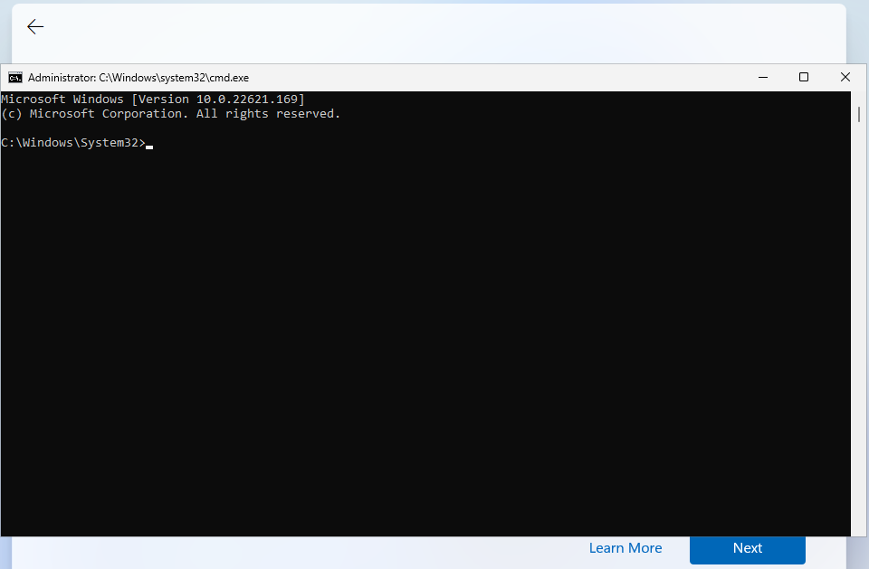
3. Type OOBE\BYPASSNRO to disable the Internet connection requirement.

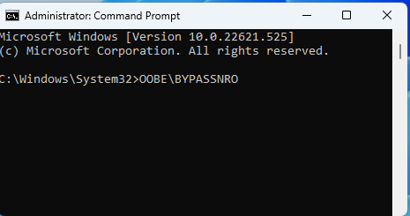
The computer will reboot and return you to this screen.
Note: if OOBE\BYPASSNRO returns a "command not found" error, skip ahead to the next method in this how-to.
4. Hit Shift + F10 again and this time Type ipconfig /release. Then hit Enter to disable the Internet. This effectively disconnects your computer from the Internet. If you're on Ethernet, you could just disconnect the plug, but this is just as easy if not easier.
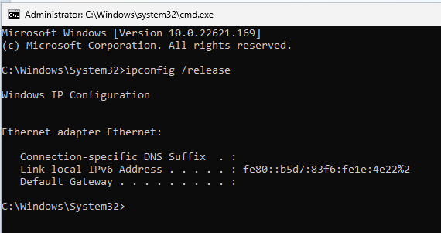
5. Close the command prompt.
6. Continue with the installation, choosing the region. keyboard and second keyboard option.
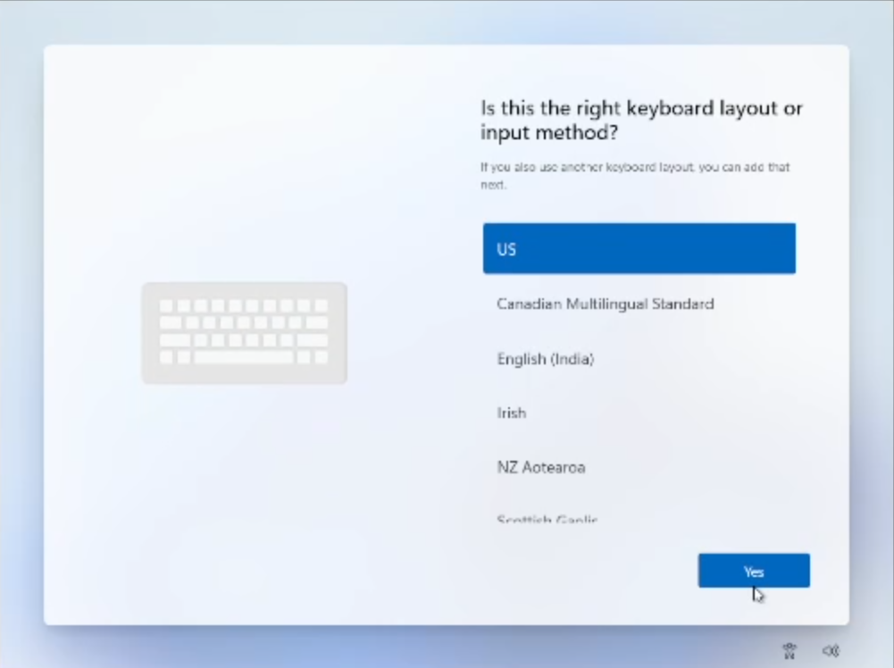

A screen saying "Let's connect you to a network" appears, warning you that you need Internet.
7. Click "I don't have Internet" to continue.
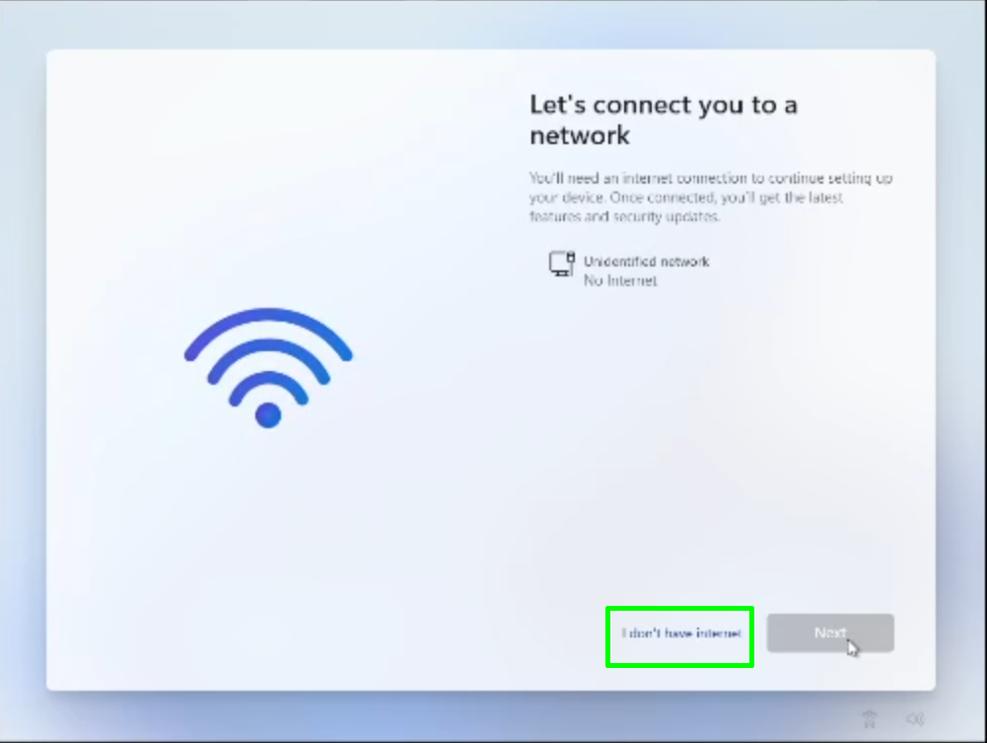
8. Click Continue with limited setup if prompted. The OOBE may skip this screen and take you straight to the next step.
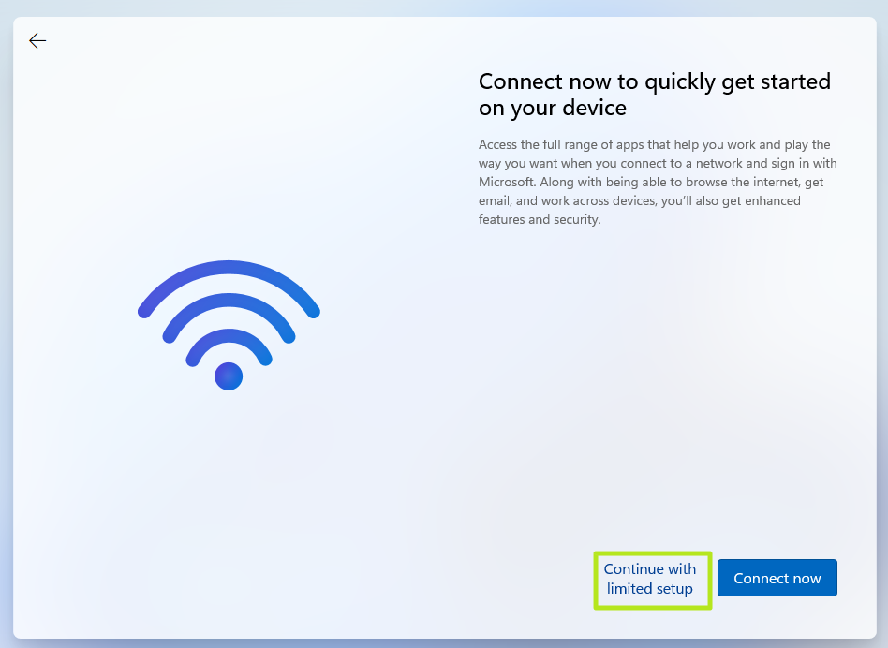
A new login screen appears asking "Who's going to use this device?"
9. Enter a username you want to use for your local Windows 11 account and click Next.
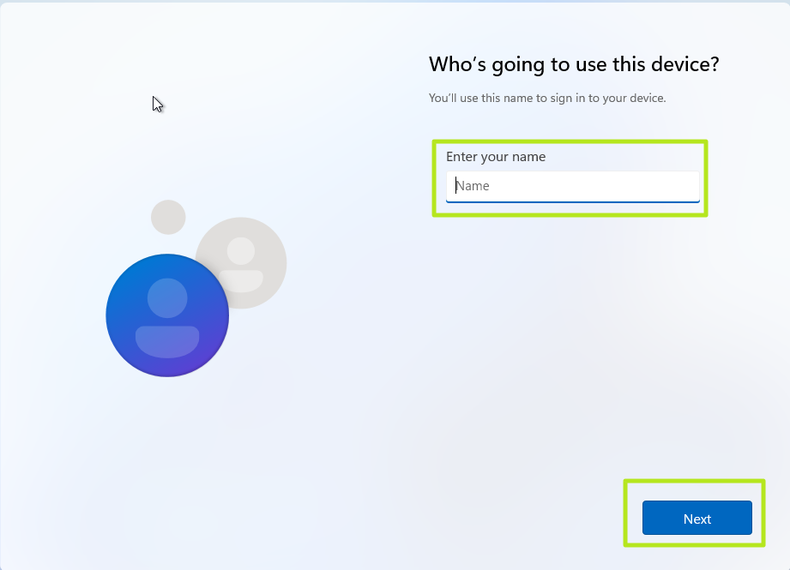
10. Enter a password you would like to use and click Next. You can also leave this field blank and have no password, but that's not recommended.
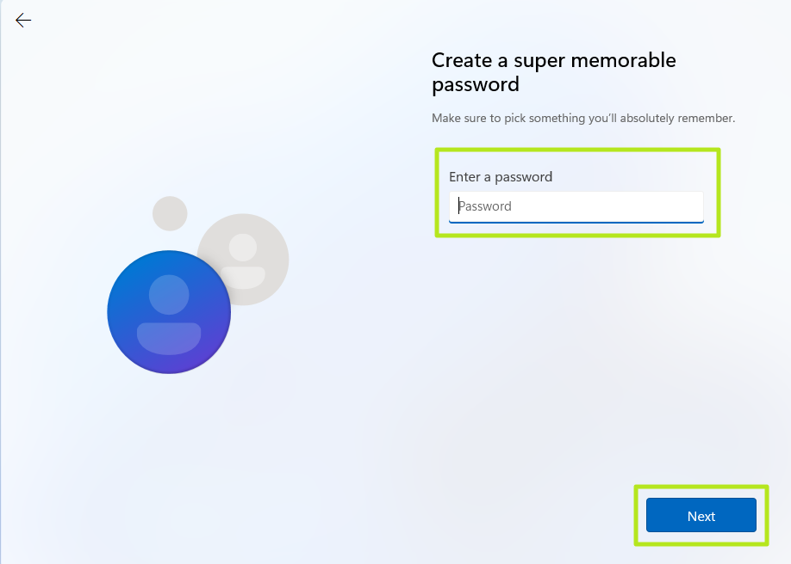
11. Complete the rest of the install process as you normally would.

How to install Windows 11 with a local account (Builds 26120 and beyond)
On new preview builds of Windows (and eventually the next release version), the OOBE/BYPASSNRO command has been erased and no longer works. Instead, there's a new command called start ms-chx:localonly that does something similar. Here's how you use it.
1. Follow the Windows 11 install process until you get to the Sign in screen.
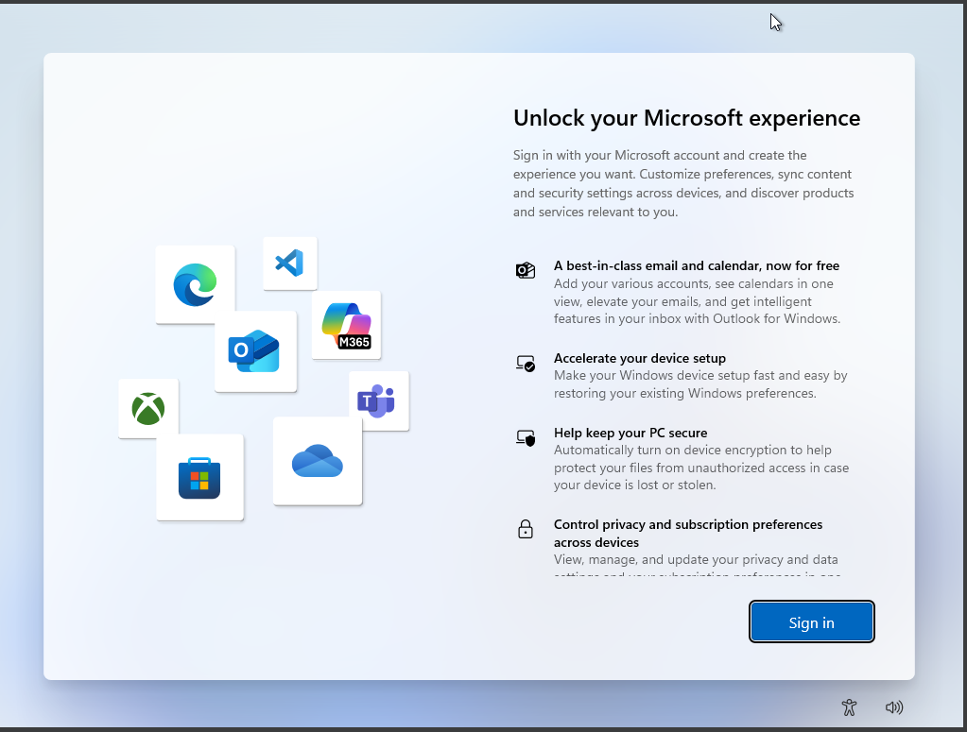
2. Hit Shift + F10. A command prompt appears.
3. Enter start ms-cxh:localonly at the command prompt.
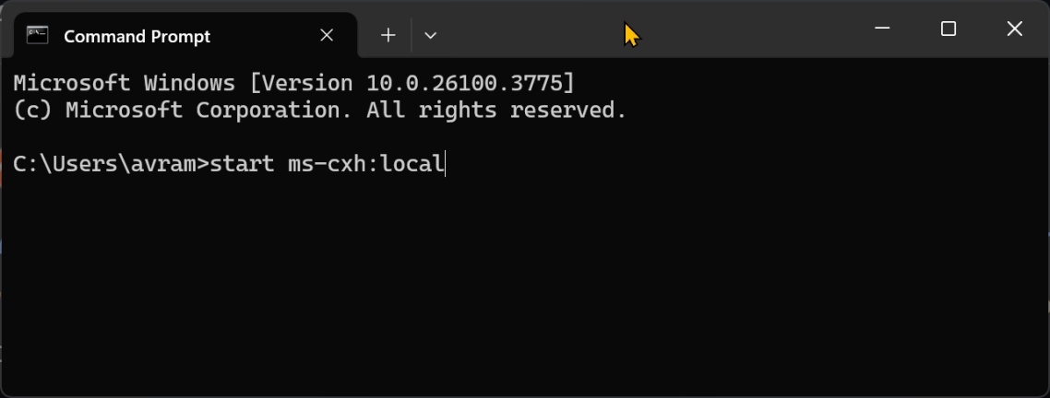
A "Create a user for this PC" dialog window appears.
4. Enter a local username and password. If you enter no password, you'll have no password.
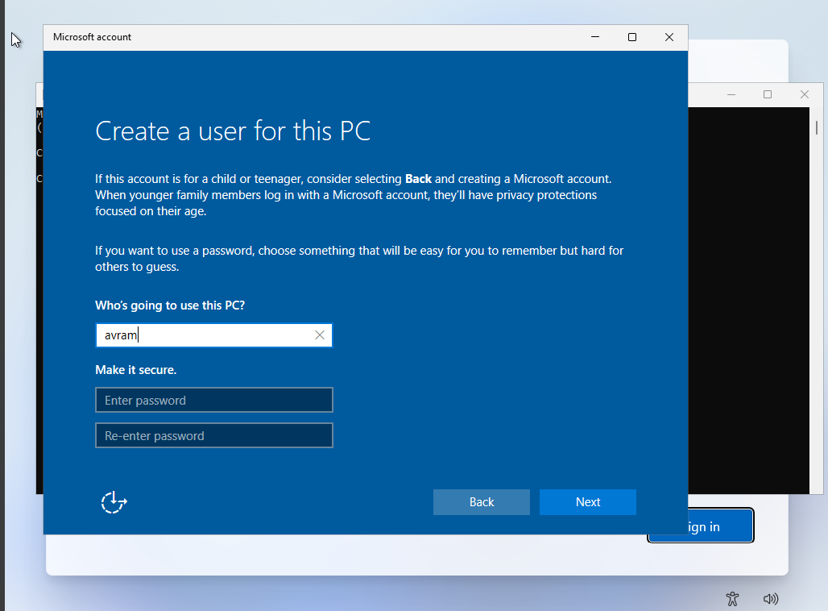
5. Complete the installation process and you'll be using the local account you created.

